**Lab 01**

**Objectives:**

1. Login to MySQL Server
2. Create the College database
3. Exploring the College database

**Tasks:**

**Create Database:**

Login to MySQL server using your MySQL username and password. If this your first time connecting to MySQL server, you need to create a new connection.

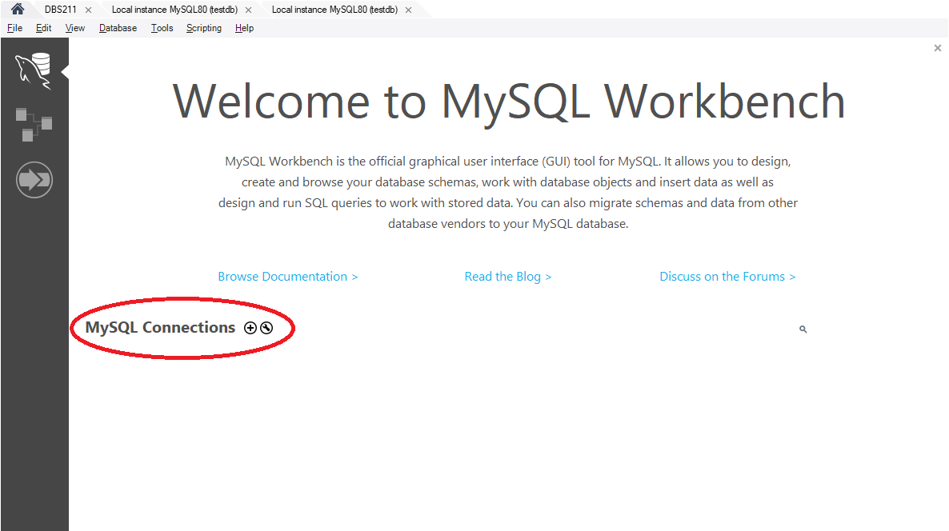

To set up a new connection, provide the hostname and the username.

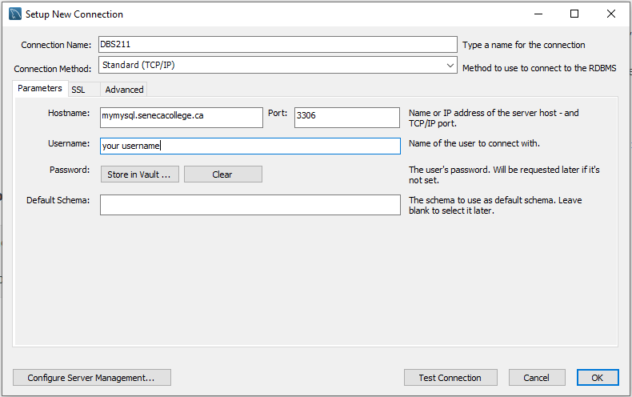

You will be asked to enter the password when you want to connect to the server.

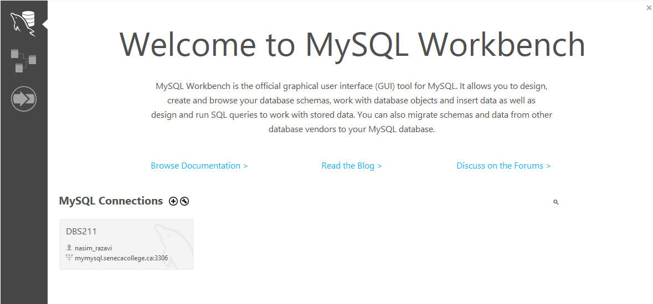

Choose the connection you have created and enter the password.

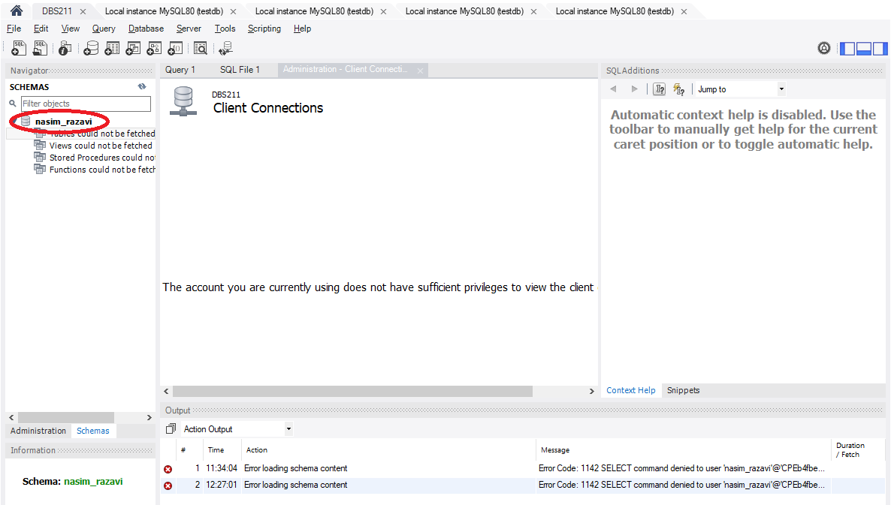

The name of your schema (database) on the Seneca server is the same as your username. Next, you need to create a database and its tables. Execute the provided SQL script. To open and execute these scripts, from the **File** menu, choose the **Open SQL Script**.

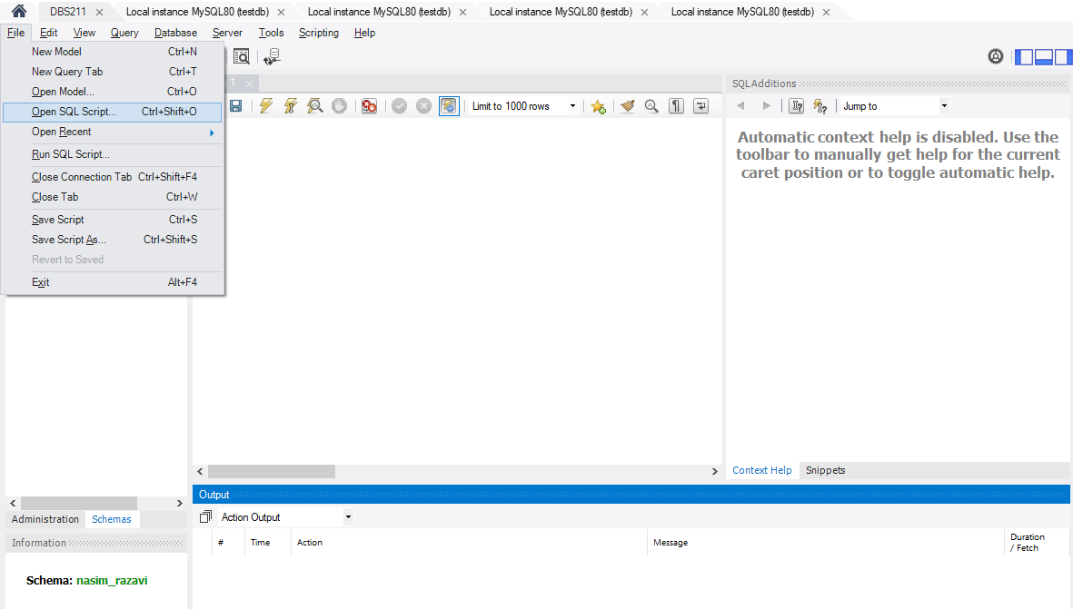

Open the folder containing the scripts and select the database-creation.sql script to be opened.

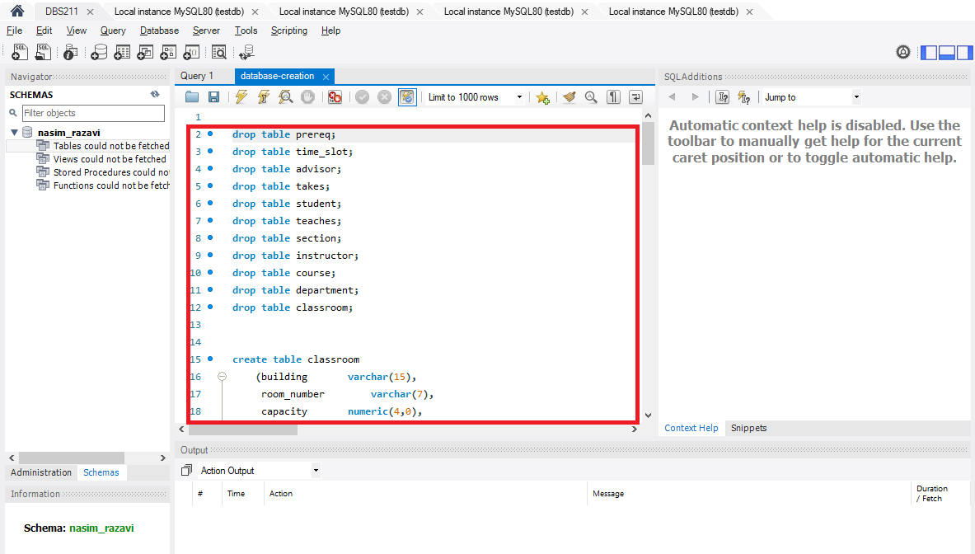

All SQL statements will be loaded into the query tab. To execute the script, press the execution button (specified with a green circle) to execute the all statements.

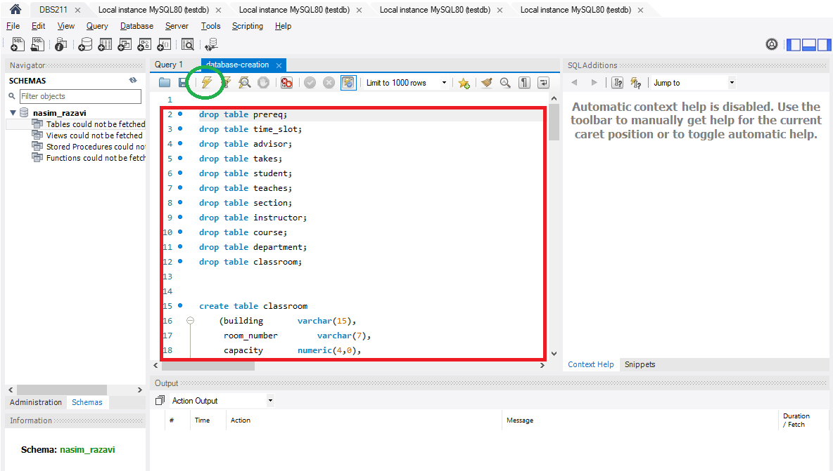

If there is any error, you can see them in the output panel. If there is no error you could successfully create the database tables.

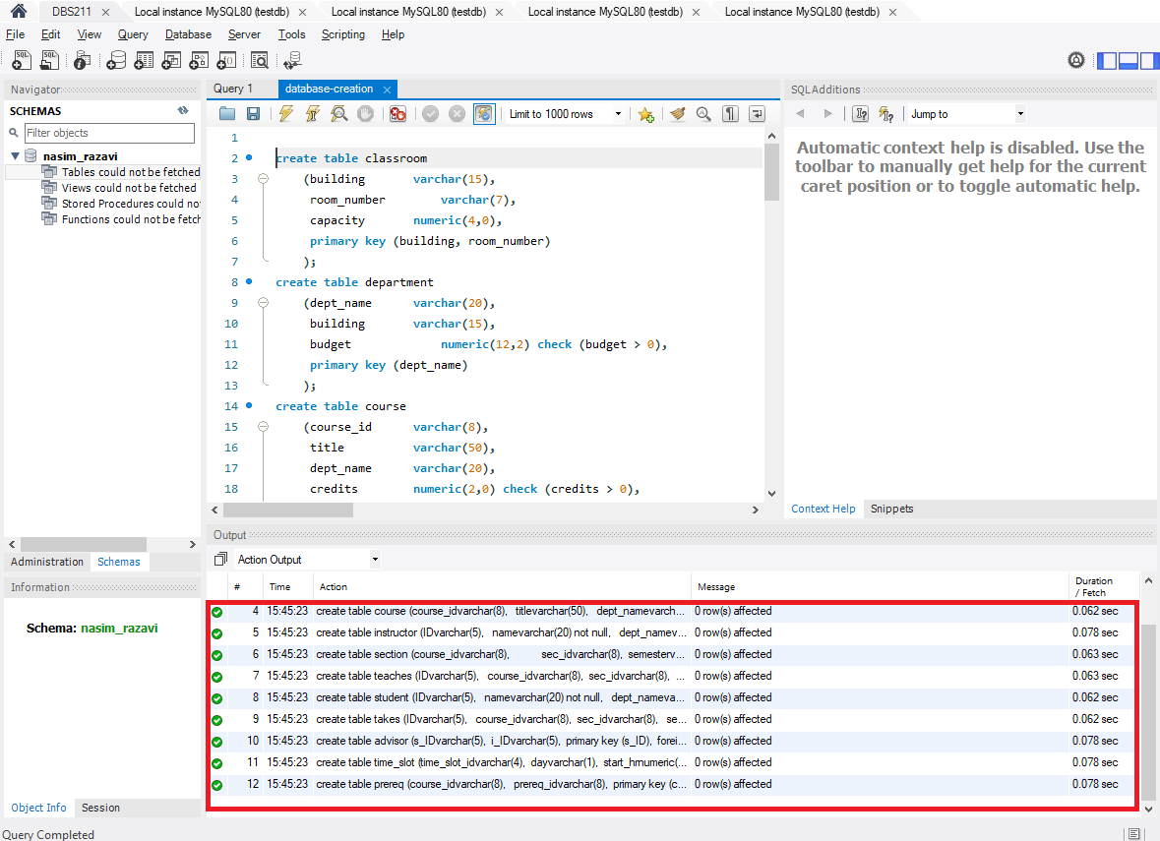

Take the same steps to load and execute the data-insertion.sql script to insert data in to your tables. Make sure the script is executed successfully with no error.

**Explore the Database**

In the object browser, expand **Tables.**

1. How many tables have been created? List the name of created tables.

_________________________________________________________________________

_________________________________________________________________________

_________________________________________________________________________

_________________________________________________________________________

_________________________________________________________________________

1. Right click on table **customers**. Select the first option **Select Rows – Limit 1000**.

How many rows are selected from table **customers**?

_________________________________________________________________________

1. What SQL statement is executed in the SQL tab after selecting **Select Rows – Limit 1000**. Write the statement in the space provided below.

_________________________________________________________________________

You will learn how to select rows and columns from a table by writing SQL select statements later in this course.

1. How many columns does the **customers** table have? List the column names.

_________________________________________________________________________

_________________________________________________________________________

1. What is the value of each column in the first row in table **customers**? Write the column name and the column value.

_________________________________________________________________________

_________________________________________________________________________

_________________________________________________________________________

_________________________________________________________________________

1. Write the number of rows and columns for the rest of the tables in your schema.

Table Name Rows Columns

__________ _____ _______  
__________ _____ _______

__________ _____ _______

__________ _____ _______

__________ _____ _______

__________ _____ _______

__________ _____ _______

__________ _____ _______

__________ _____ _______

__________ _____ _______

__________ _____ _______

__________ _____ _______

1. Right click on table **employees**. Select **Alter Table**. In the column subtab, you can see the list of columns and edit them. Do not modify any column.

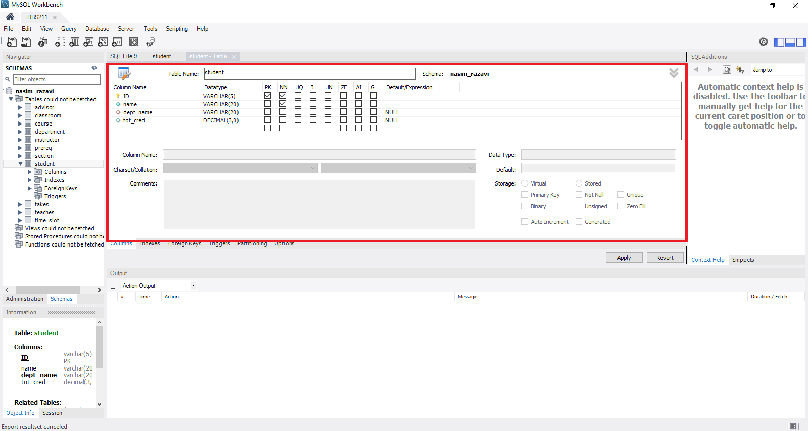

List the column names and types for table **employees**.

Column Name Column Type

__________ ___________   
__________ ___________

__________ ___________

__________ ___________

__________ ___________

__________ ___________

__________ ___________

__________ ___________

__________ ___________

1. Open a new SQL tab.

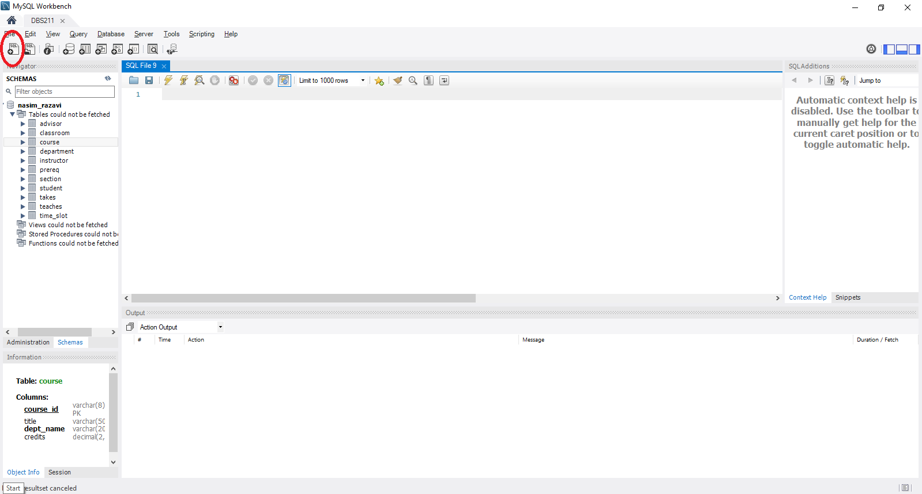

Write the following SQL statement in the new tab.

desc offices;

You can also write

describe offices;

Select the run button to execute the statement. See the next image for the execution button.

What is the result of the statement execution?

